EXPT. NO: 5 | I/O STATEMENTS AND EXPRESSIONS
DATE:8.1.2020 | I/O STATEMENTS AND EXPRESSIONS
Aim:
To write a C program for the following
- Find area and volume of shapes
- Convert centigrade to Fahrenheit
- Swap two numbers with and without using temporary variable
1.Find area and volume of shapes
Area of a circle
Area of a Rectangle
Area of a Triangle
Area of a Square
Volume of a Sphere
Volume of cylinder
Volume of cube
Volume of cone
Algorithm
- Start the program
- Read the values of radius, length, breadth, side, base and height
- Compute area=3.14*radius*radius [Area Of Circle]
- Compute area=length*breadth [Area Of Rectangle]
- Compute area=(breadth* height)/2 [Area Of Triangle]
- Compute area= side*side [Area Of Square]
- Compute Volume=(4/3) * 3.14 * radius * radius * radius [Volume of Sphere]
- Compute Volume=3.14 * radius * radius * height [Volume of Cylinder]
- Compute Volume= length * length * length [Volume of Cube]
- Compute Volume= 3. 14 * radius * radius * (height /3) [Volume of Cone]
- Print the value of area of the shape (or) Print the value of volume of the shape
- Stop the program
Flowchart
Area of a circle
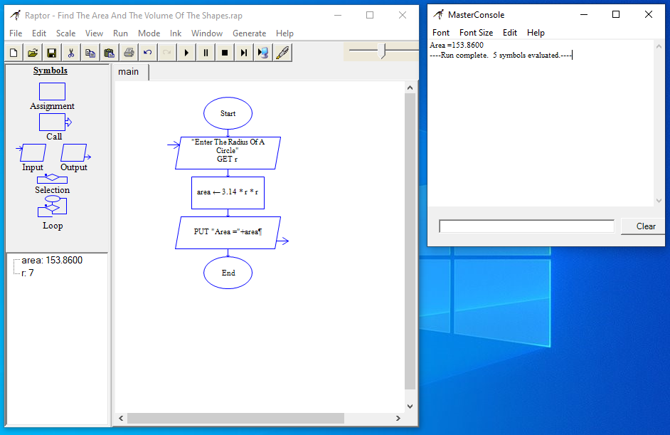

Area of a Rectangle
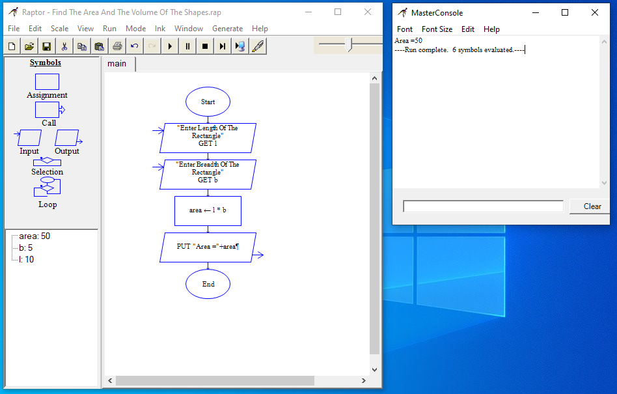
Area of a Triangle
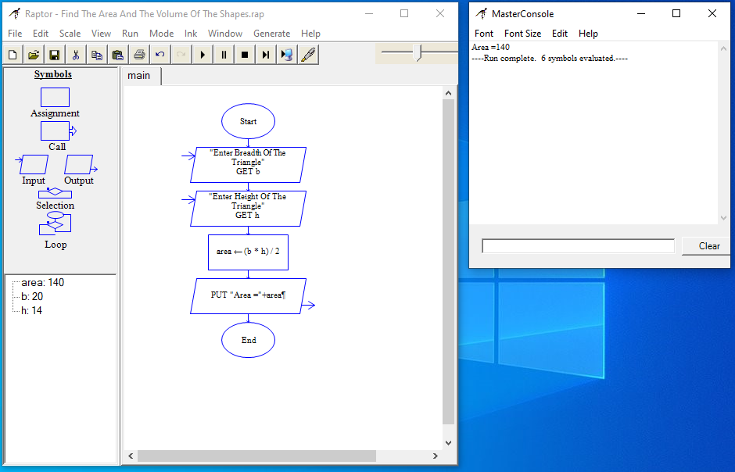
Area of a Square
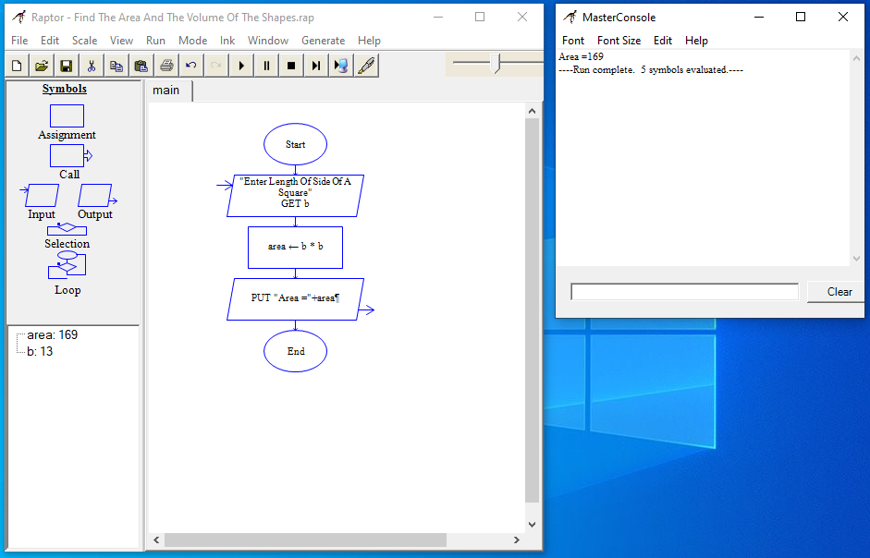
Volume of a Sphere
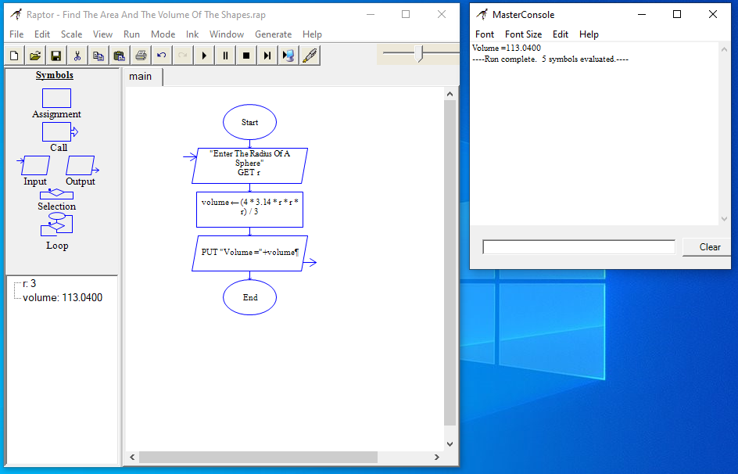
Volume of cylinder
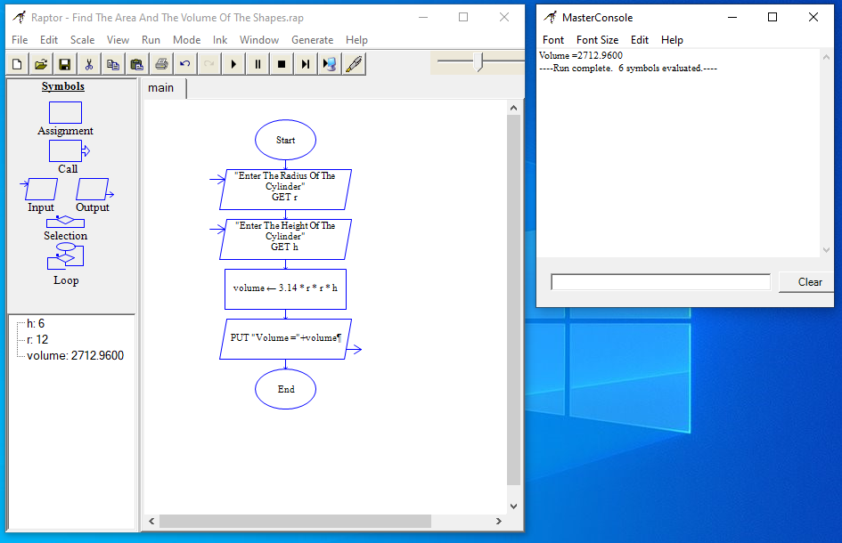
Volume of cube
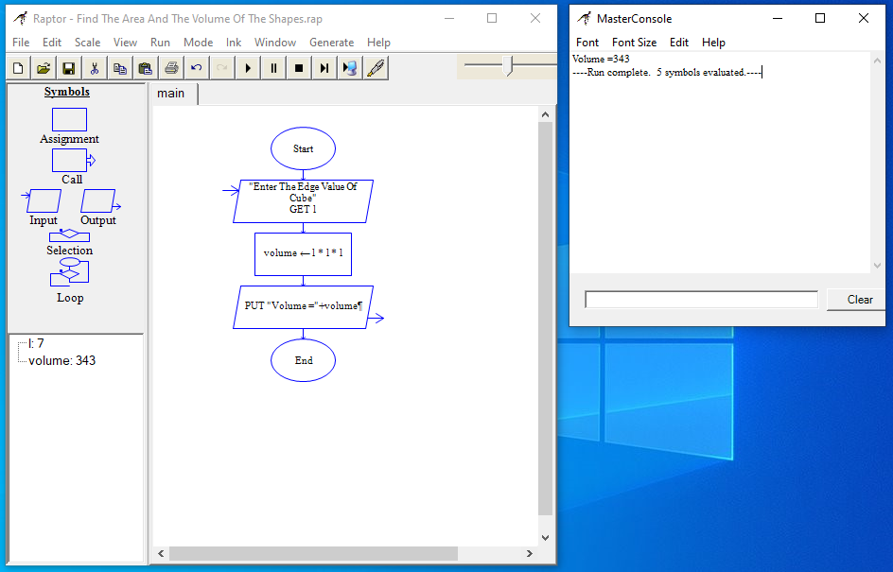
Volume of cone
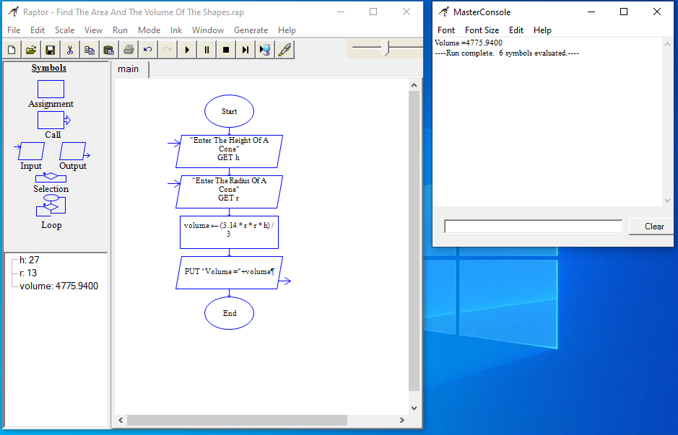
Program
#include <stdio.h>
int main()
{
int a;
float l, b, h, r;
printf("Select The Function To Find The Area And The Volume Of The Shapes:\n");
printf("Area Of The Shapes:\n");
printf("\t1.Circle\n\t2. Rectangle\n\t3. Triangle\n\t4.Square\n");
printf("Volume Of The Shapes:\n");
printf("\t5.Sphere\n\t6.Cylinder\n\t7.Cube\n\t8.Cone\n\n");
printf("Please Enter The Shape Numbers: ");
scanf("%d", &a);
if(a == 1) {
printf("Enter The Radius Of A Circle: ");
scanf("%f", &r);
printf("Area = %.2f \n", 3.14*r*r);
} else if(a == 2) {
printf("Enter Length Of The Rectangle: ");
scanf("%f", &l);
printf("Enter Breadth Of The Rectangle: ");
scanf("%f", &b);
printf("Area = %.2f \n", l*b);
} else if(a == 3) {
printf("Enter Breadth Of The Triangle: ");
scanf("%f", &b);
printf("Enter Height Of The Triangle: ");
scanf("%f", &h);
printf("Area = %.2f \n", (b*h)/2);
} else if(a == 4) {
printf("Enter Length Of Side Of A Square: ");
scanf("%f", &b);
printf("Area = %.2f \n", b*b);
} else if(a == 5) {
printf("Enter The Radius Of A Sphere: ");
scanf("%f", &r);
printf("Volume = %.2f \n", (4/3)*3.14*r*r*r);
} else if(a == 6) {
printf("Enter The Radius Of The Cylinder: ");
scanf("%f", &r);
printf("Enter The Height Of The Cylinder: ");
scanf("%f", &h);
printf("Volume = %.2f \n", 3.14*r*r*h);
} else if(a == 7) {
printf("Enter The Edge Value Of Cube: ");
scanf("%f", &l);
printf("Volume = %.2f \n", l*l*l);
} else if(a == 8) {
printf("Enter The Height Of A Cone: ");
scanf("%f", &h);
printf("Enter The Radius Of A Cone: ");
scanf("%f", &r);
printf("Volume = %.2f \n", 3.14*r*r*(h/3));
} else {
printf("You Have Entered Wrong Option\n");
}
return 0;
}
Output
Area of a circle
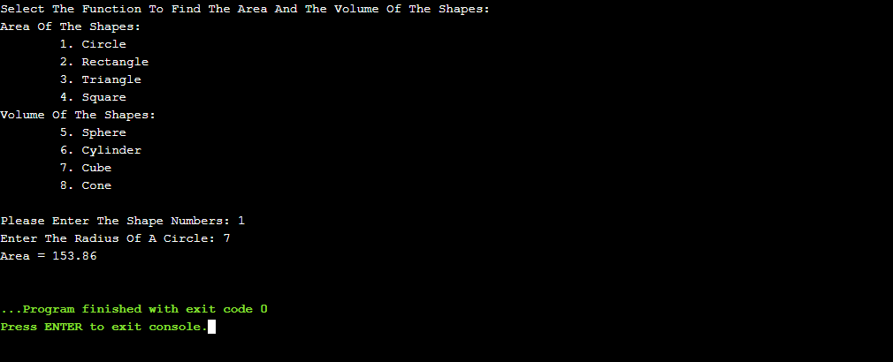
Area of a Rectangle
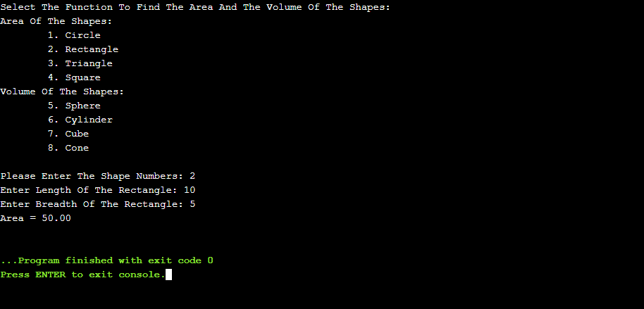
Area of a Triangle
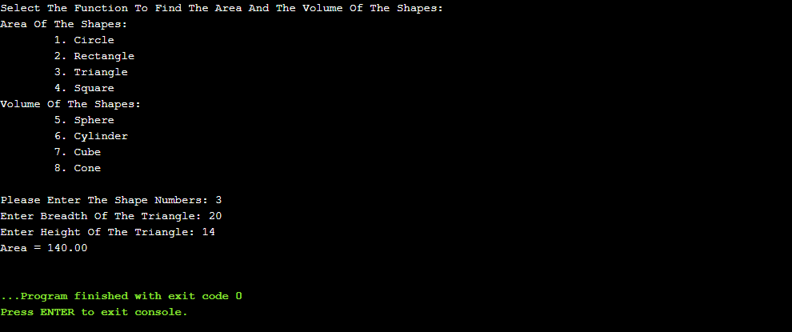
Area of a Square
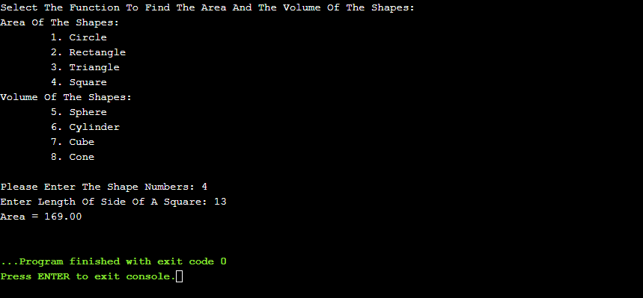
Volume of a Sphere
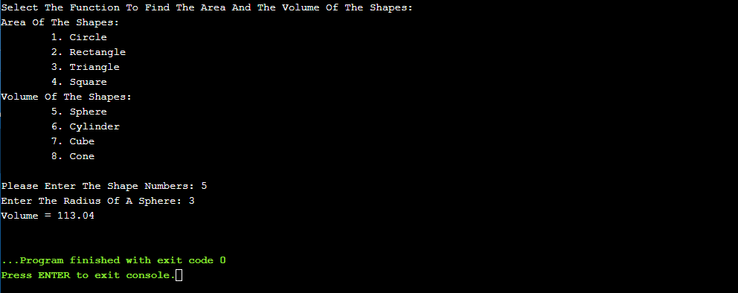
Volume of cylinder
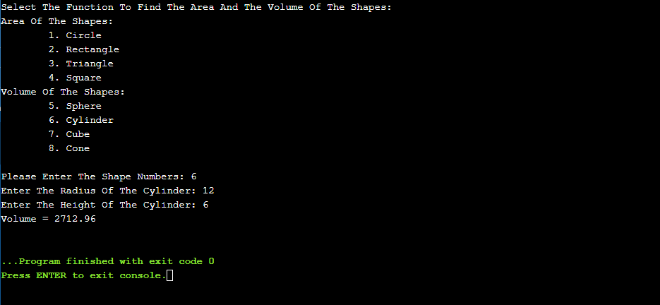
Volume of cube
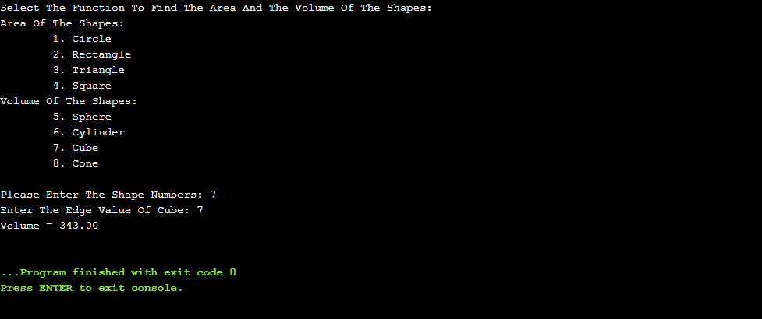
Volume of cone
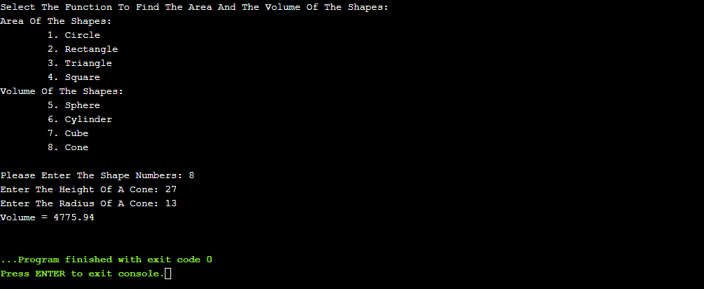

Convert centigrade to Fahrenheit
Algorithm
- Start the program
- Read the values of celsius, and fahrenheit
- Compute fahrenheit = (celsius * 9 / 5) + 32
- Print the value of fahrenheit
- Stop the program
Flowchart
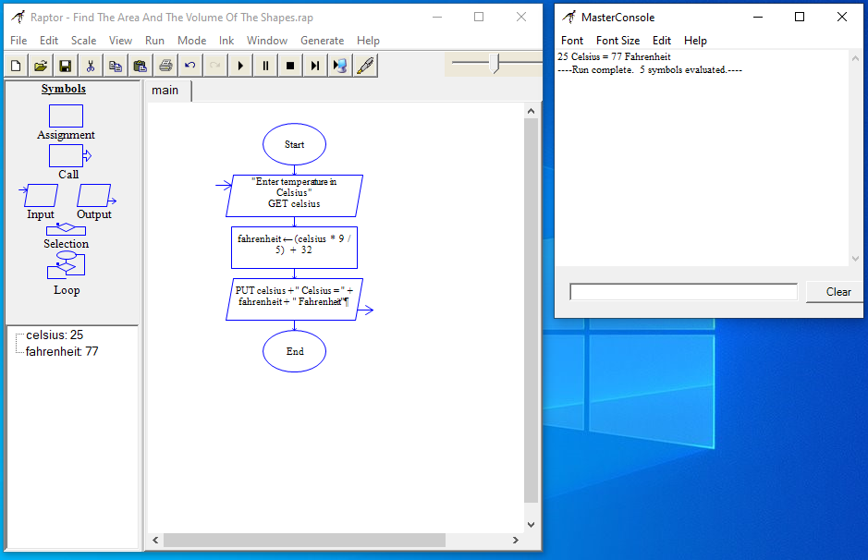
Program
#include <stdio.h>
int main()
{
float c, f;
printf("Enter temperature in Celsius: ");
scanf("%f", &c);
f = (c * 9 / 5) + 32;
printf("%.2f Celsius = %.2f Fahrenheit", c, f);
return 0;
}
Output
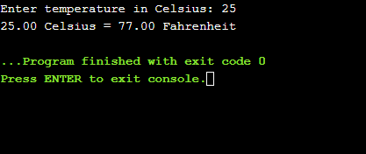
Swap two numbers with and without using temporary variable
Algorithm
With Temporary Variable
- Start the program
- Read the values of num1, and num2
- Compute temp = num1
- Compute num1 = num2
- Compute num2 = temp
- Print the value of num1 and num2
- Stop the program
Without Using Temporary Variable
- Start the program
- Read the values of num1, and num2
- Compute num1 = num1 + num2
- Compute num2 = num1 - num2
- Compute num1 = num1 - num2
- Print the value of num1 and num2
- Stop the program

Flowchart
With Temporary Variable
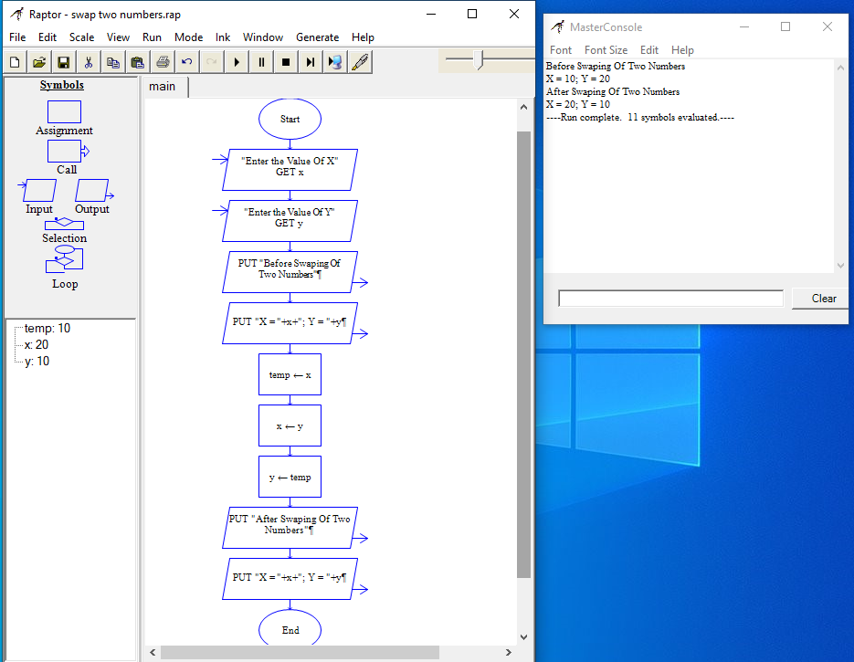
Without Using Temporary Variable
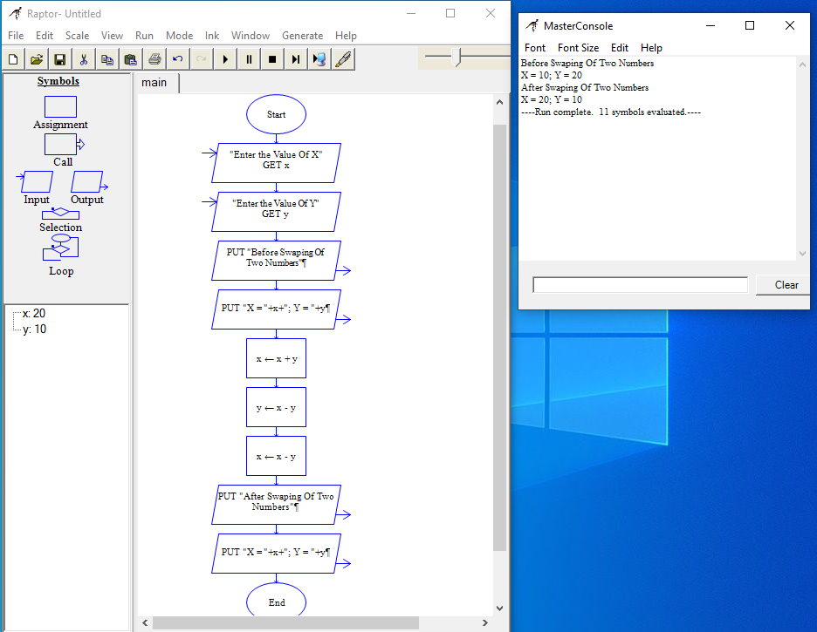
Program
With Temporary Variable
#include <stdio.h>
int main()
{
int temp, x, y;
printf("Enter the Value Of X: ");
scanf("%d", &x);
printf("Enter the Value Of Y: ");
scanf("%d", &y);
printf("Before Swaping Of Two Numbers\n");
printf("X = %d ; Y = %d", x, y);
temp = x;
x = y;
y = temp;
printf("\nAfter Swaping Of Two Numbers\n");
printf("X = %d ; Y = %d", x, y);
return 0;
}
Without Using Temporary Variable
#include <stdio.h>
int main()
{
int x, y;
printf("Enter the Value Of X: ");
scanf("%d", &x);
printf("Enter the Value Of Y: ");
scanf("%d", &y);
printf("Before Swaping Of Two Numbers\n");
printf("X = %d ; Y = %d", x, y);
x=x+y;
y=x-y;
x=x-y;
printf("\nAfter Swaping Of Two Numbers\n");
printf("X = %d ; Y = %d", x, y);
return 0;
}
Output
With Temporary Variable And Without Using Temporary Variable
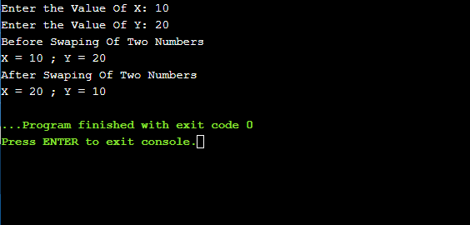
Result
Thus the C program was written and executed successfully for the following
- Find area and volume of shapes
- Convert centigrade to Fahrenheit
- Swap two numbers with and without using temporary variable

